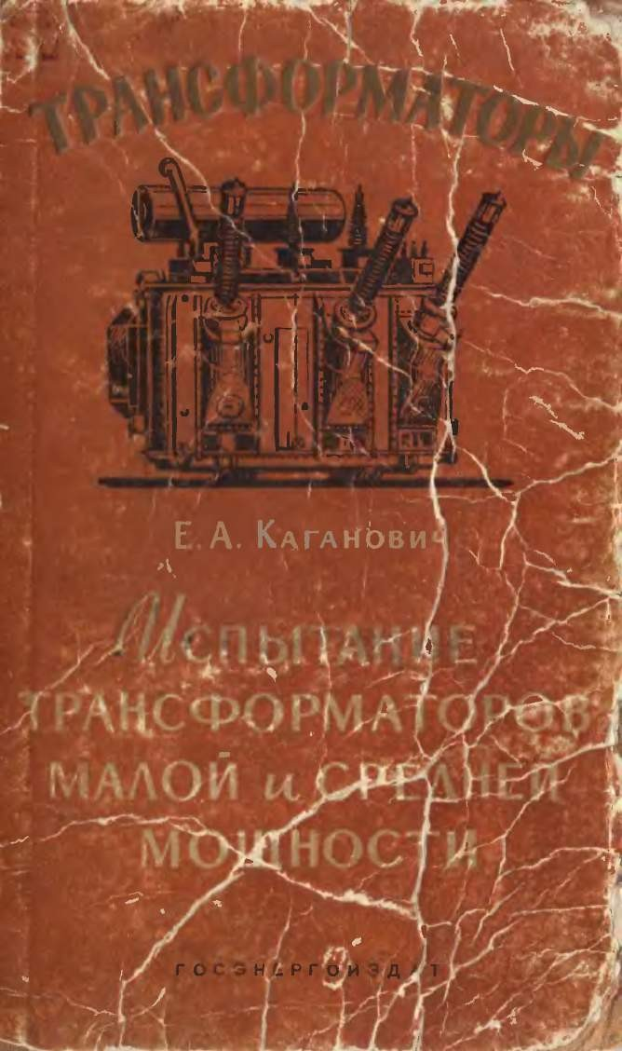

W. fl. hD8OpgO8J

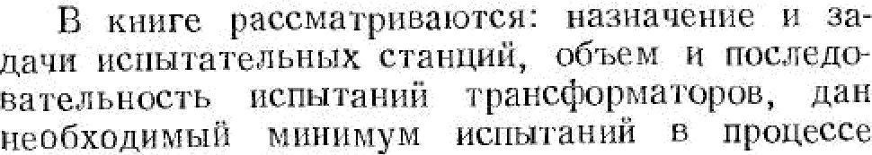
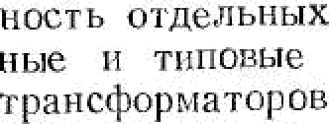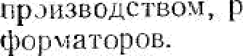FI P E O H fi N O B II E
ncnuzaiiiiii, Onflcaiiu KO ei ’po,nb-
cnuzaHiin, npiisiepi•i ucnuraHim
OiHOC’rov Ao o600 xao.
KH! rIl
iicpHt3- e
iIpentia3iiaqeria use
p
aauuu aioiz xcm

t6opx , uann+exa

ofissarezarian nOCzenoBazera-
xpyr uirrazcmefi

5 600 K8O)
minrtoM paf›trre Mooxnacxore wc§x›pMa-

COM M6tQ on next s ue+onOB HOIlos’HiHlls vpillHi O)M h9XljRJiB,
lI'HbIfi e Kg hI Ill MBlICn pd1BHO'C11u 'B TQ6itlCQopMayas, +I Me-
Y'trr biBaii Bospam aioulee Kmiuuecrno zp a-ucQopMam piibIX
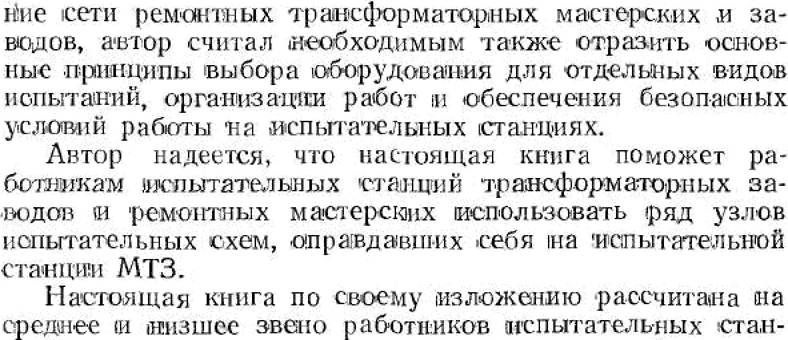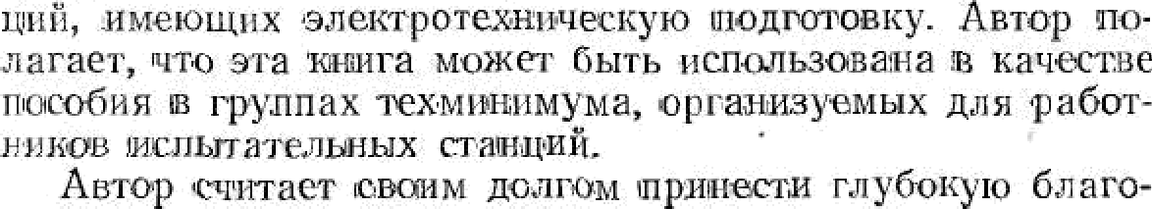ycza xonor o c›lKTeMe u apooHoro xoasilfTBa COGP, pacuiiipe-

gap b mm. H. II. C'KBopuoay ix xao,q. mKo. biaya
E. H. Fee pay sa cx u8H.Hbie coBezai rips pa6ore can py-
flOAMHC8HOE MtV4’£Id
19. 3 ne'i.
Aarop

Thank you for using www.freepdfconvert.com service!

Only two pages are converted. Please Sign Up to convert all pages. https://www.freepdfconvert.com/membership

