06N0TkH

X k30A9I\l19
CH10BidX

MACA9NMX

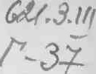
T P A H C & O P M A T O P bl
Bentley 19

z. c. r E ACHMOBA » A. H. MAFIOPEIJ,

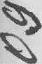OBMO’FKH H H3ONH HH CHJIOBbIX MACNHHbIX TPAHC&OPMATOPOB
(TeX onOPHu H opra sauHs
HJ3OH3BOacTBa)

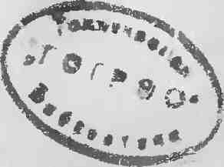

«3 H E P FH IJ»

MOCf(BA 1969

Thank you for using www.freepdfconvert.com service!

Only two pages are converted. Please Sign Up to convert all pages. https://www.freepdfconvert.com/membership

